Sphere-Based Repeated Composite Solids

Definition
# Source: AI Source: Provided by: [Data Path: Persons Table -> ID Column: 1, Name_En Column: Motasem Essam] -> From: [ChatGPT] on [7/25/2026]
Sphere-Based Repeated Composite Solids are three-dimensional geometric structures formed by combining two or more spheres in a repeated pattern or arrangement.
The spheres may have identical or different radii and can be positioned in linear sequences, stacked arrangements, clusters, symmetrical patterns, or other configurations.
They may touch one another at points, be connected through truncated planar regions, or be embedded in a larger structure. Their resulting external shape depends on the number, dimensions, and spatial arrangement of the spheres.

Simple Definition
# Source: AI Source: Provided by: [Data Path: Persons Table -> ID Column: 1, Name_En Column: Motasem Essam] -> From: [ChatGPT] on [7/25/2026]
A sphere-based repeated composite solid is a 3D structure made by combining multiple spheres in a repeated arrangement.
For example, several identical spheres arranged in a row or grouped around a central sphere form sphere-based repeated composite structures.

Geometric Representation
# Source: AI Source: Provided by: [Data Path: Persons Table -> ID Column: 1, Name_En Column: Motasem Essam] -> From: [ChatGPT] on [7/25/2026]
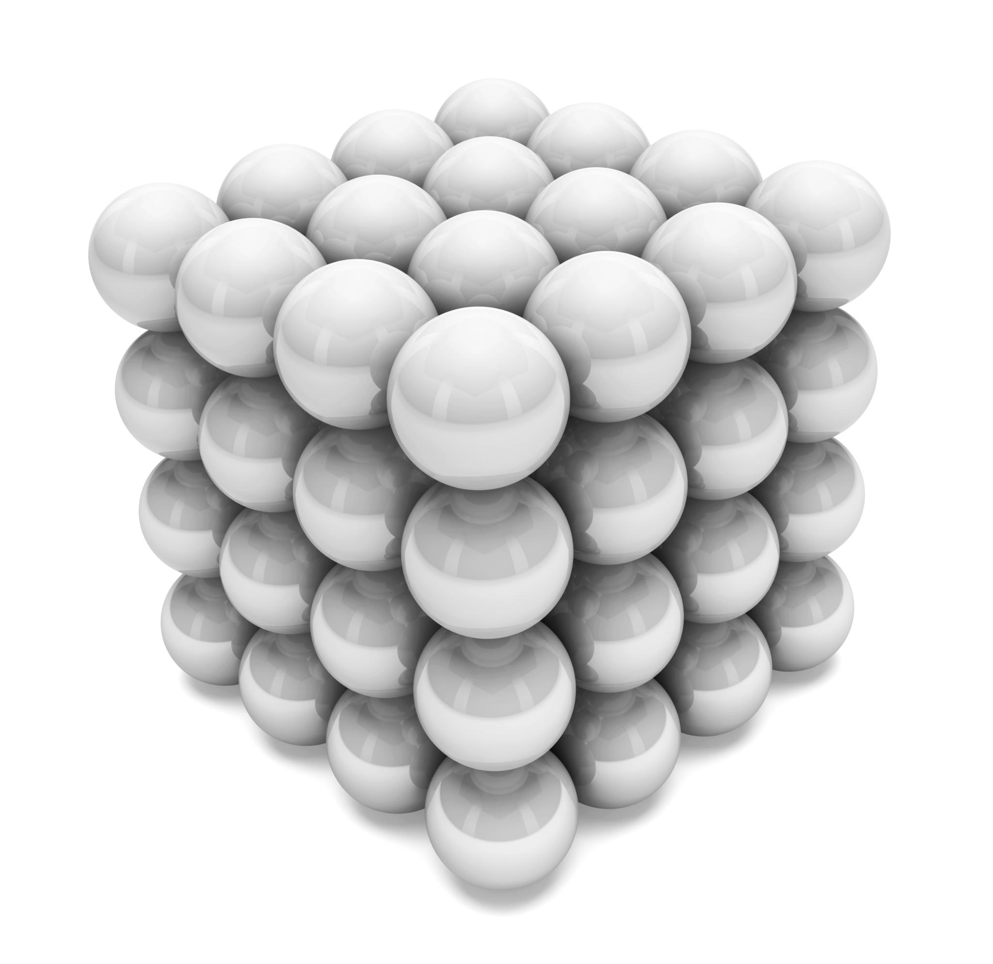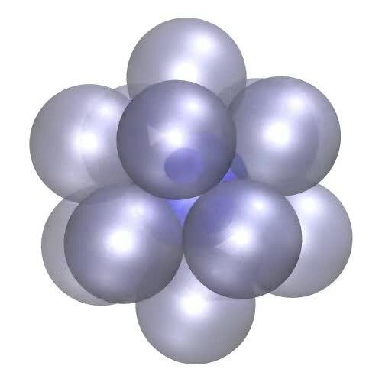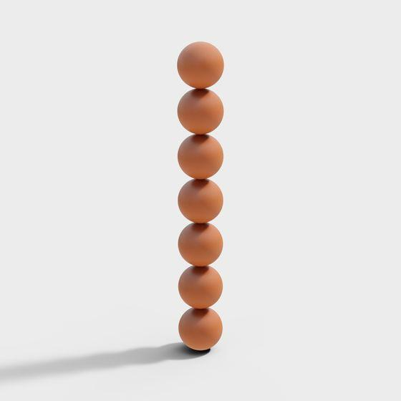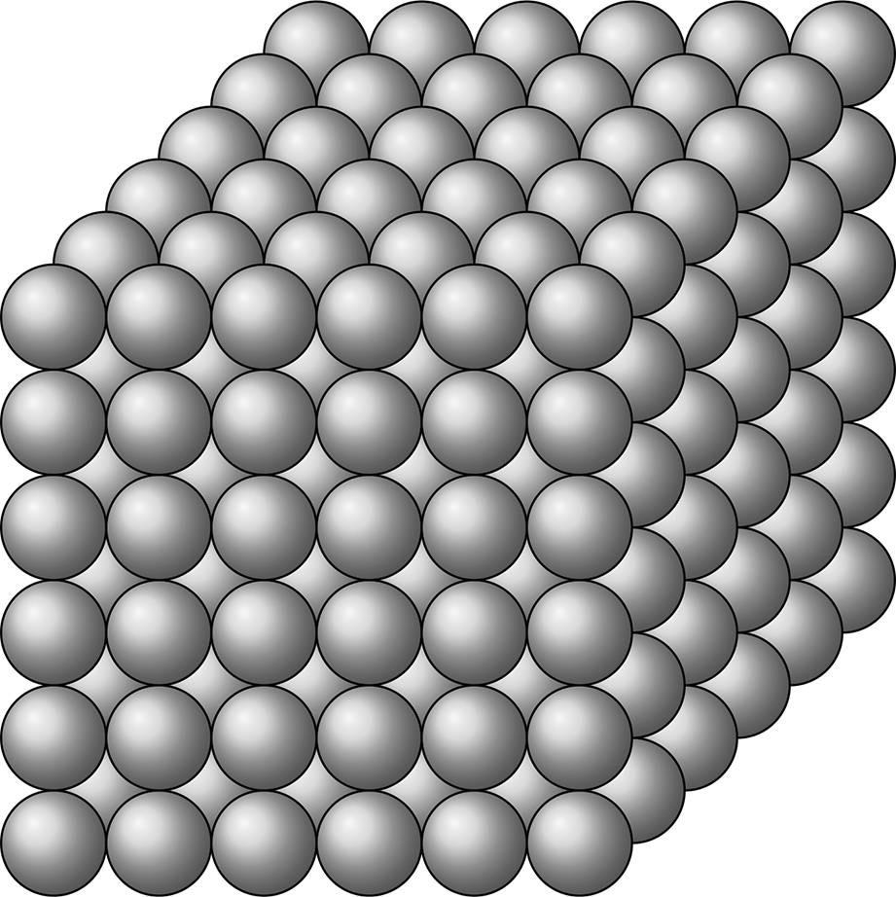
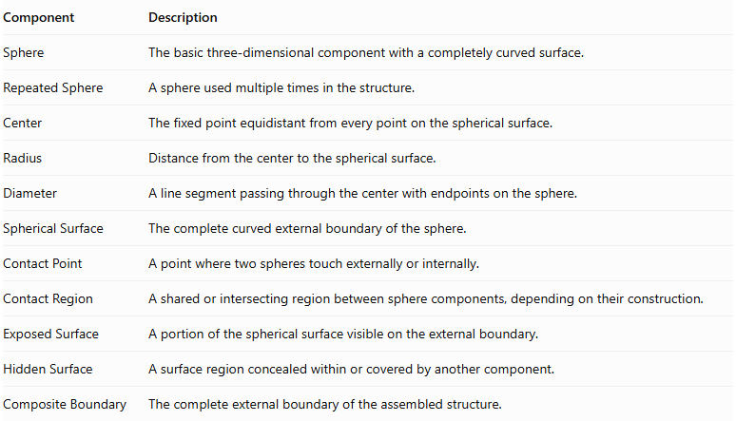
Component | Description
Sphere | The basic three-dimensional component with a completely curved surface.
Repeated Sphere | A sphere used multiple times in the structure.
Center | The fixed point equidistant from every point on the spherical surface.
Radius | Distance from the center to the spherical surface.
Diameter | A line segment passing through the center with endpoints on the sphere.
Spherical Surface | The complete curved external boundary of the sphere.
Contact Point | A point where two spheres touch externally or internally.
Contact Region | A shared or intersecting region between sphere components, depending on their construction.
Exposed Surface | A portion of the spherical surface visible on the external boundary.
Hidden Surface | A surface region concealed within or covered by another component.
Composite Boundary | The complete external boundary of the assembled structure.
Important: Two complete spheres that merely touch externally have point contact, not a shared joining face. They form a connected collection, but not a conventional face-connected solid. More complex sphere-based solids can be formed by intersecting, fusing, or truncating their components.

Types of Sphere-Based Repeated Composite Solids

Linear Sphere-Based Composite Solids
# Source: AI Source: Provided by: [Data Path: Persons Table -> ID Column: 1, Name_En Column: Motasem Essam] -> From: [ChatGPT] on [7/25/2026]
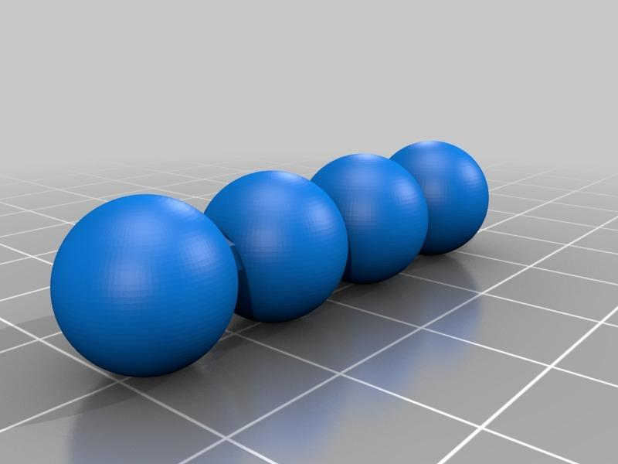
Formed by arranging spheres in a straight sequence along one direction.
Types include:
- Horizontal Linear Arrangement.
- Vertical Linear Arrangement.
- Depth-Wise Linear Arrangement.
- Equal-Radius Linear Arrangement.
- Different-Radius Linear Arrangement.
- Alternating-Size Linear Arrangement.

Clustered Sphere-Based Composite Solids
# Source: AI Source: Provided by: [Data Path: Persons Table -> ID Column: 1, Name_En Column: Motasem Essam] -> From: [ChatGPT] on [7/25/2026]
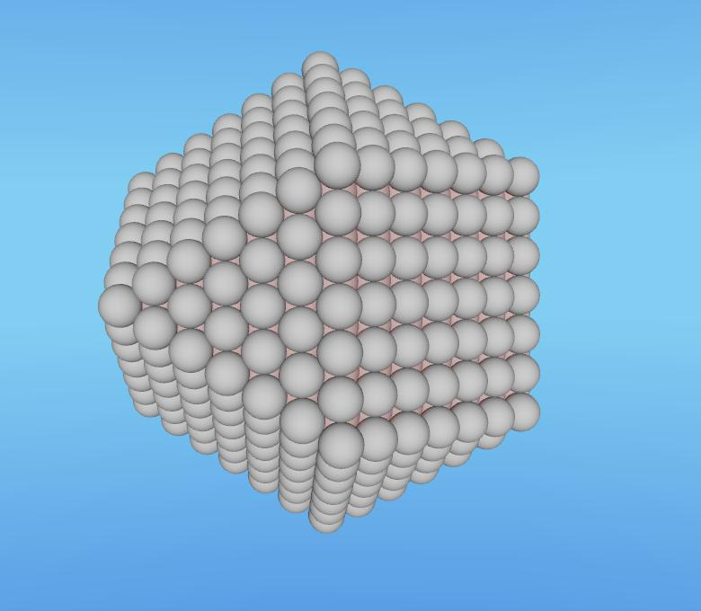
Formed by grouping multiple spheres into a compact three-dimensional cluster.
Types include:
- Compact Sphere Cluster.
- Symmetrical Sphere Cluster.
- Asymmetrical Sphere Cluster.
- Equal-Radius Sphere Cluster.
- Different-Radius Sphere Cluster.
- Multi-Level Sphere Cluster.

Stacked Sphere-Based Composite Solids
# Source: AI Source: Provided by: [Data Path: Persons Table -> ID Column: 1, Name_En Column: Motasem Essam] -> From: [ChatGPT] on [7/25/2026]

Formed by arranging spheres vertically in successive levels.
Types include:
- Equal-Size Stacked Spheres.
- Different-Size Stacked Spheres.
- Progressively Enlarged Sphere Stack.
- Progressively Reduced Sphere Stack.
- Alternating-Size Sphere Stack.
- Multi-Level Sphere Stack.

Coaxial Sphere-Based Composite Solids
# Source: AI Source: Provided by: [Data Path: Persons Table -> ID Column: 1, Name_En Column: Motasem Essam] -> From: [ChatGPT] on [7/25/2026]

Formed by positioning the centers of multiple spheres along one common straight line.
Types include:
- Equal-Radius Coaxial Arrangement.
- Different-Radius Coaxial Arrangement.
- Equally Spaced Coaxial Arrangement.
- Unequally Spaced Coaxial Arrangement.
- Symmetrical Coaxial Arrangement.
- Asymmetrical Coaxial Arrangement.

Radial Sphere-Based Composite Solids
# Source: AI Source: Provided by: [Data Path: Persons Table -> ID Column: 1, Name_En Column: Motasem Essam] -> From: [ChatGPT] on [7/25/2026]
Formed by arranging spheres around a central sphere or central region.
Types include:
- Two-Direction Radial Arrangement.
- Three-Sphere Radial Arrangement.
- Four-Sphere Radial Arrangement.
- Circular Radial Arrangement.
- Symmetrical Radial Arrangement.
- Multi-Layer Radial Arrangement.

Ring-Shaped Sphere-Based Composite Solids
# Source: AI Source: Provided by: [Data Path: Persons Table -> ID Column: 1, Name_En Column: Motasem Essam] -> From: [ChatGPT] on [7/25/2026]

Formed by arranging spheres around a circular path, creating a ring-like configuration.
Types include:
- Single-Ring Arrangement.
- Double-Ring Arrangement.
- Equal-Radius Ring Arrangement.
- Different-Radius Ring Arrangement.
- Horizontal Ring Arrangement.
- Vertical Ring Arrangement.

Pyramid-Like Sphere-Based Composite Solids
# Source: AI Source: Provided by: [Data Path: Persons Table -> ID Column: 1, Name_En Column: Motasem Essam] -> From: [ChatGPT] on [7/25/2026]
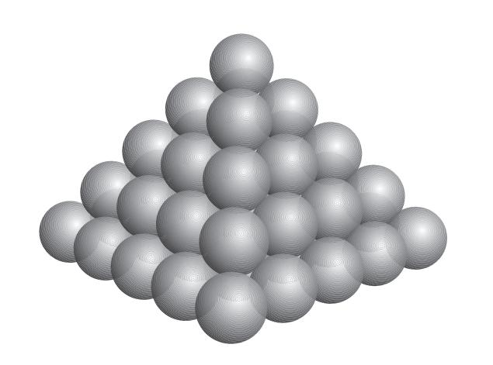
Formed by arranging spheres in progressively smaller layers to create a pyramid-like configuration.
Types include:
- Triangular-Layered Arrangement.
- Square-Layered Arrangement.
- Tetrahedral Sphere Arrangement.
- Square-Pyramid Sphere Arrangement.
- Symmetrical Sphere Pyramid.
- Multi-Level Sphere Pyramid.

Grid-Based Sphere-Based Composite Solids
# Source: AI Source: Provided by: [Data Path: Persons Table -> ID Column: 1, Name_En Column: Motasem Essam] -> From: [ChatGPT] on [7/25/2026]
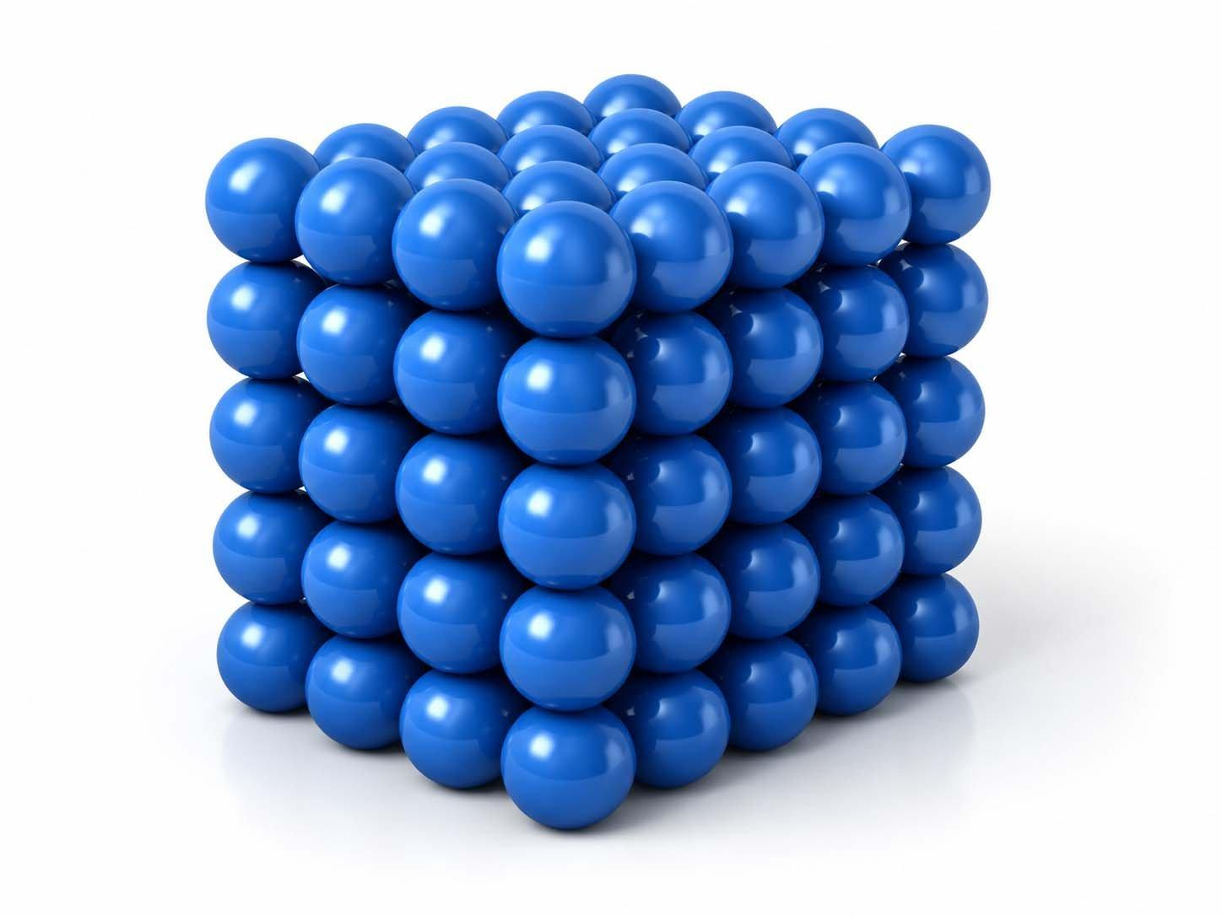
Formed by arranging spheres in a regular three-dimensional grid.
Types include:
- Linear Grid Arrangement.
- Rectangular Grid Arrangement.
- Cubic Grid Arrangement.
- Layered Grid Arrangement.
- Uniform Grid Arrangement.
- Non-Uniform Grid Arrangement.

Nested Sphere-Based Composite Solids
# Source: AI Source: Provided by: [Data Path: Persons Table -> ID Column: 1, Name_En Column: Motasem Essam] -> From: [ChatGPT] on [7/25/2026]
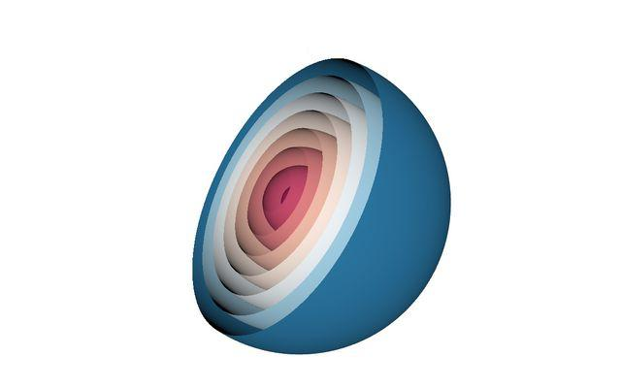
Formed by positioning one spherical component inside another spherical component.
Types include:
- Two Concentric Spheres.
- Multiple Concentric Spheres.
- Nested Hollow Spheres.
- Nested Spherical Shells.
- Concentric Layered Sphere Arrangement.
- Mixed-Size Nested Sphere Arrangement.
These configurations generally describe hollow or shell-based structures. Complete solid spheres cannot be nested inside one another as non-overlapping solid components while remaining entirely within the same space.

Symmetrical Sphere-Based Composite Solids
# Source: AI Source: Provided by: [Data Path: Persons Table -> ID Column: 1, Name_En Column: Motasem Essam] -> From: [ChatGPT] on [7/25/2026]
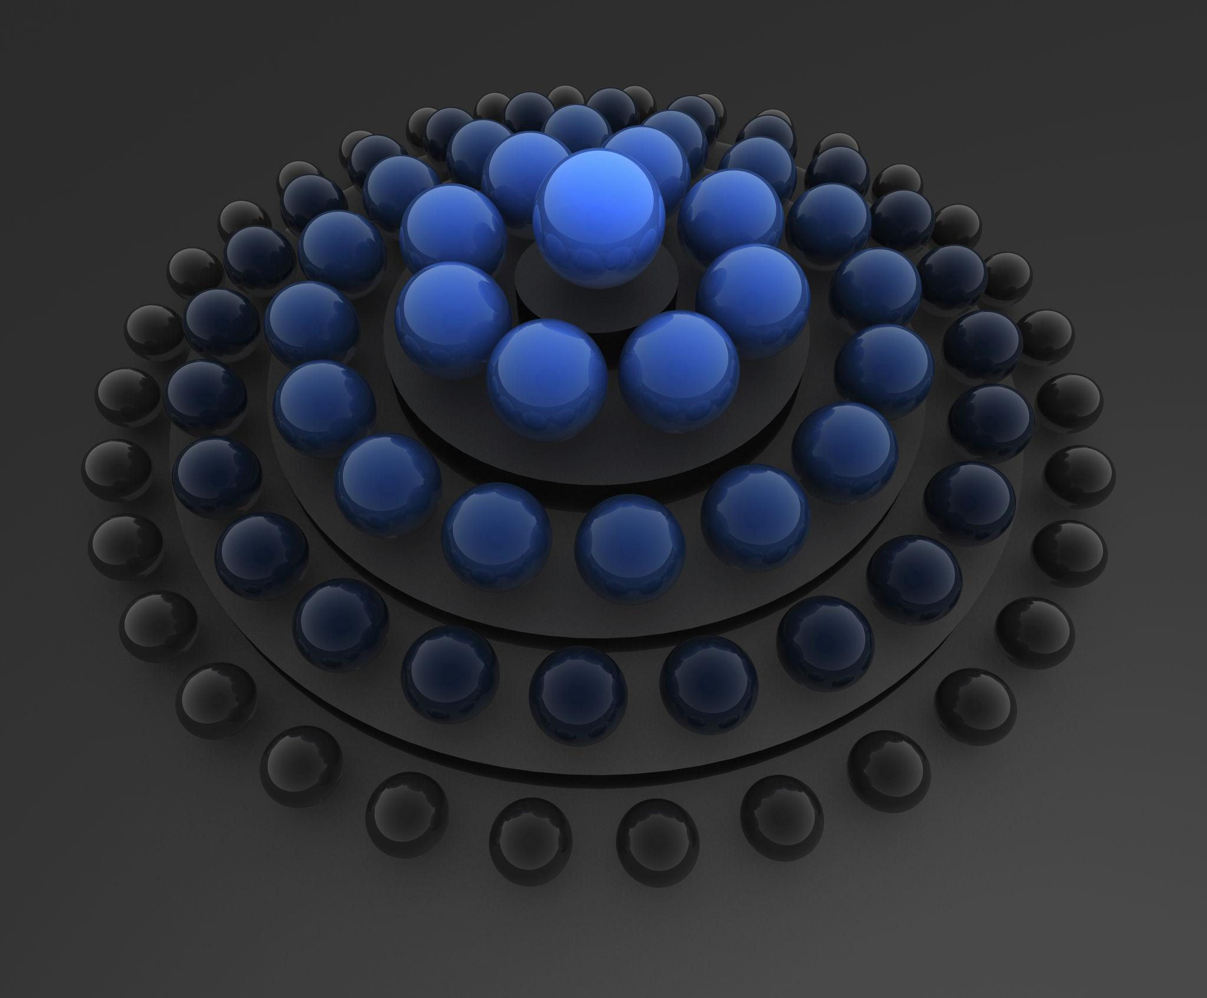
Formed by arranging spheres so that the overall structure has one or more symmetry properties.
Types include:
- Reflection-Symmetrical Arrangement.
- Rotationally Symmetrical Arrangement.
- Axially Symmetrical Arrangement.
- Centrally Symmetrical Arrangement.
- Radially Symmetrical Arrangement.

Irregular Sphere-Based Composite Solids
# Source: AI Source: Provided by: [Data Path: Persons Table -> ID Column: 1, Name_En Column: Motasem Essam] -> From: [ChatGPT] on [7/25/2026]

Formed by combining spheres in a non-uniform arrangement without a regular overall pattern.
Types include:
- Random Sphere Arrangement.
- Uneven Multi-Level Arrangement.
- Asymmetrical Arrangement.
- Mixed-Radius Arrangement.
- Complex Intersecting Arrangement.
- Irregular Sphere Cluster.

Classification by Sphere Arrangement
# Source: AI Source: Provided by: [Data Path: Persons Table -> ID Column: 1, Name_En Column: Motasem Essam] -> From: [ChatGPT] on [7/25/2026]
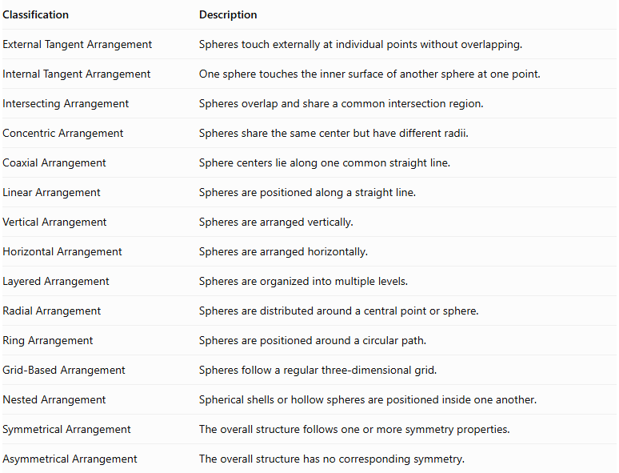
Classification | Description
External Tangent Arrangement | Spheres touch externally at individual points without overlapping.
Internal Tangent Arrangement | One sphere touches the inner surface of another sphere at one point.
Intersecting Arrangement | Spheres overlap and share a common intersection region.
Concentric Arrangement | Spheres share the same center but have different radii.
Coaxial Arrangement | Sphere centers lie along one common straight line.
Linear Arrangement | Spheres are positioned along a straight line.
Vertical Arrangement | Spheres are arranged vertically.
Horizontal Arrangement | Spheres are arranged horizontally.
Layered Arrangement | Spheres are organized into multiple levels.
Radial Arrangement | Spheres are distributed around a central point or sphere.
Ring Arrangement | Spheres are positioned around a circular path.
Grid-Based Arrangement | Spheres follow a regular three-dimensional grid.
Nested Arrangement | Spherical shells or hollow spheres are positioned inside one another.
Symmetrical Arrangement | The overall structure follows one or more symmetry properties.
Asymmetrical Arrangement | The overall structure has no corresponding symmetry.

Classification by Number and Dimensions of Spheres
# Source: AI Source: Provided by: [Data Path: Persons Table -> ID Column: 1, Name_En Column: Motasem Essam] -> From: [ChatGPT] on [7/25/2026]
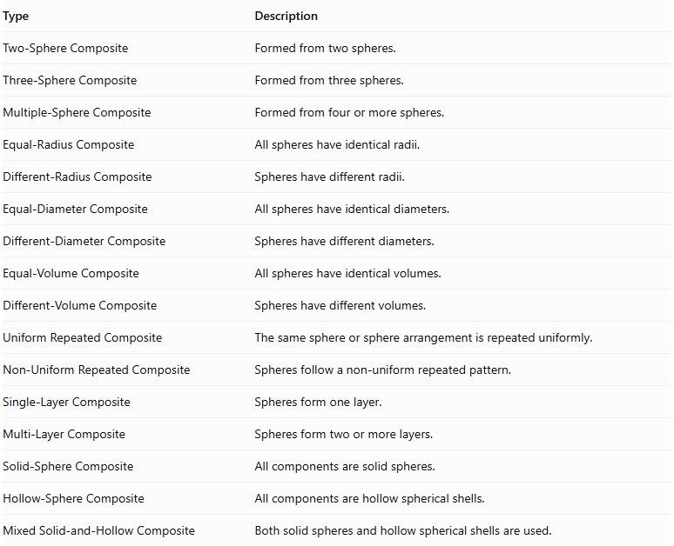
Type | Description
Two-Sphere Composite | Formed from two spheres.
Three-Sphere Composite | Formed from three spheres.
Multiple-Sphere Composite | Formed from four or more spheres.
Equal-Radius Composite | All spheres have identical radii.
Different-Radius Composite | Spheres have different radii.
Equal-Diameter Composite | All spheres have identical diameters.
Different-Diameter Composite | Spheres have different diameters.
Equal-Volume Composite | All spheres have identical volumes.
Different-Volume Composite | Spheres have different volumes.
Uniform Repeated Composite | The same sphere or sphere arrangement is repeated uniformly.
Non-Uniform Repeated Composite | Spheres follow a non-uniform repeated pattern.
Single-Layer Composite | Spheres form one layer.
Multi-Layer Composite | Spheres form two or more layers.
Solid-Sphere Composite | All components are solid spheres.
Hollow-Sphere Composite | All components are hollow spherical shells.
Mixed Solid-and-Hollow Composite | Both solid spheres and hollow spherical shells are used.

Mathematical Properties and Formulas

Volume of One Sphere
# Source: AI Source: Provided by: [Data Path: Persons Table -> ID Column: 1, Name_En Column: Motasem Essam] -> From: [ChatGPT] on [7/25/2026]
The volume of a sphere is:
$$\boxed{V_{sphere}=\frac{4}{3}πr^{3}}$$
Where:
- $r$ = radius of the sphere.
- $π≈3.14159$.

Total Volume of Equal Spheres
# Source: AI Source: Provided by: [Data Path: Persons Table -> ID Column: 1, Name_En Column: Motasem Essam] -> From: [ChatGPT] on [7/25/2026]
For $n$ identical spheres:
$$\boxed{V_{total}=\frac{4}{3}nπr^{3}}$$
Where:
- $n$ = number of spheres.
- $r$ = radius of each sphere.

Total Volume of Different Spheres
# Source: AI Source: Provided by: [Data Path: Persons Table -> ID Column: 1, Name_En Column: Motasem Essam] -> From: [ChatGPT] on [7/25/2026]
When the spheres have different radii:
$$\boxed{V_{total}=\frac{4}{3}π\sum_{i=1}^{n}{r_{i}^{3}}}$$
This formula assumes that the spheres do not overlap internally.
If spheres intersect, their overlapping volumes must be subtracted from the sum to avoid double-counting.

Surface Area of One Sphere
# Source: AI Source: Provided by: [Data Path: Persons Table -> ID Column: 1, Name_En Column: Motasem Essam] -> From: [ChatGPT] on [7/25/2026]
The surface area of a sphere is:
$$\boxed{{SA}_{sphere}=4πr^{2}}$$

Surface Area of Repeated Spheres
# Source: AI Source: Provided by: [Data Path: Persons Table -> ID Column: 1, Name_En Column: Motasem Essam] -> From: [ChatGPT] on [7/25/2026]
For $n$ separate identical spheres:
$$\boxed{{SA}_{separate}=4nπr^{2}}$$
For spheres that touch externally at individual points without overlapping, the total external surface area remains the sum of their individual surface areas:
$$\boxed{{SA}_{total}=4π\sum_{i=1}^{n}{r_{i}^{2}}}$$
Point contacts have zero surface area, so they do not hide any finite portion of the spherical surfaces.
Important: When spheres intersect or overlap, the external surface area is not simply the sum of their individual surface areas. The hidden spherical regions must be excluded, and the exposed portions must be calculated.

Special Formula for Concentric Spherical Shells
# Source: AI Source: Provided by: [Data Path: Persons Table -> ID Column: 1, Name_En Column: Motasem Essam] -> From: [ChatGPT] on [7/25/2026]
For two concentric spheres with outer radius $R$ and inner radius $r$, the volume of the spherical shell is:
$$\boxed{V_{shell}=\frac{4}{3}π(R^{3}-r^{3})}$$
Its total boundary surface area, including the inner and outer spherical surfaces, is:
$$\boxed{{SA}_{shell}=4πR^{2}+4πr^{2}}$$
This formula applies to a complete spherical shell with both surfaces included.

Special Formula for a Spherical Cluster
# Source: AI Source: Provided by: [Data Path: Persons Table -> ID Column: 1, Name_En Column: Motasem Essam] -> From: [ChatGPT] on [7/25/2026]
For a collection of $n$ non-overlapping spheres with different radii that touch only at individual points:
$$\boxed{V_{cluster}=\frac{4}{3}π\sum_{i=1}^{n}{r_{i}^{3}}}$$
$$\boxed{{SA}_{cluster}=4π\sum_{i=1}^{n}{r_{i}^{2}}}$$
The formulas apply when the spheres do not overlap and their contact regions are only points.

Worked Examples

Example 1: Linear Sphere-Based Composite Solid
# Source: AI Source: Provided by: [Data Path: Persons Table -> ID Column: 1, Name_En Column: Motasem Essam] -> From: [ChatGPT] on [7/25/2026]
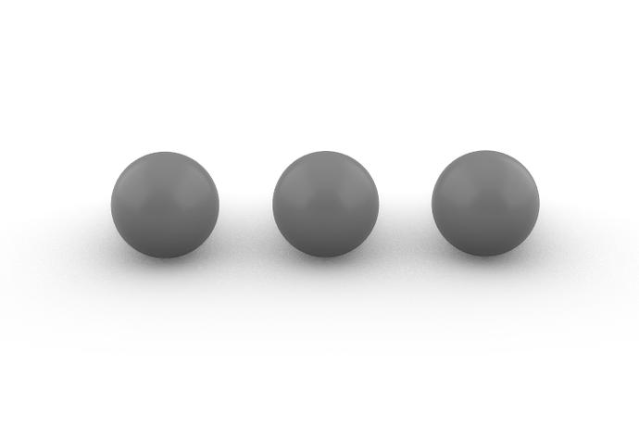
Given:
- Number of spheres: $n=3$.
- Radius of each sphere: $r=2 cm$.
- Arrangement: horizontal linear arrangement.
- The spheres touch externally at individual points without overlapping.
Step 1: Calculate the volume of one sphere.
$$V_{1}=\frac{4}{3}πr^{3}$$
$$V_{1}=\frac{4}{3}π(2)^{3}$$
$$V_{1}=\frac{32}{3}π$$
Step 2: Calculate the total volume.
$$V_{total}=3(\frac{32}{3}π)$$
$$\boxed{V_{total}=32π≈100.53{ cm}^{3}}$$
<badge color="success">Volume = 100.53 cm³</badge>
Step 3: Calculate the surface area of one sphere.
$${SA}_{1}=4πr^{2}$$
$${SA}_{1}=4π(2)^{2}$$
$${SA}_{1}=16π$$
Step 4: Calculate the total external surface area.
Since the spheres touch only at individual points, no finite surface regions are hidden.
$${SA}_{total}=3(16π)$$
$$\boxed{{SA}_{total}=48π≈150.80{ cm}^{2}}$$
<badge color="success">Surface Area = 150.80 cm²</badge>
Final Result:
- Total Volume = $32π≈100.53{ cm}^{3}$.
- External Surface Area = $48π≈150.80{ cm}^{2}$.

Example 2: Different-Radius Sphere-Based Composite Solid
# Source: AI Source: Provided by: [Data Path: Persons Table -> ID Column: 1, Name_En Column: Motasem Essam] -> From: [ChatGPT] on [7/25/2026]
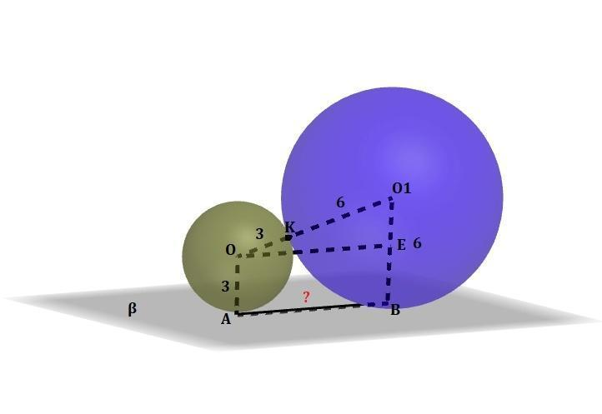
Given:
- First sphere:
- Radius: $R=3 cm$.
- Second sphere:
- Radius: $r=2 cm$.
- Arrangement: external tangent arrangement.
- The spheres touch at one point without overlapping.
Step 1: Calculate the volume of the first sphere.
$$V_{1}=\frac{4}{3}πR^{3}$$
$$V_{1}=\frac{4}{3}π(3)^{3}$$
$$V_{1}=36π$$
Step 2: Calculate the volume of the second sphere.
$$V_{2}=\frac{4}{3}πr^{3}$$
$$V_{2}=\frac{4}{3}π(2)^{3}$$
$$V_{2}=\frac{32}{3}π$$
Step 3: Calculate the total volume.
$$V_{total}=36π+\frac{32}{3}π$$
$$\boxed{V_{total}=\frac{140}{3}π≈146.61{ cm}^{3}}$$
<badge color="success">Volume = 146.61 cm³</badge>
Step 4: Calculate the surface area of the first sphere.
$${SA}_{1}=4πR^{2}$$
$${SA}_{1}=4π(3)^{2}=36π$$
Step 5: Calculate the surface area of the second sphere.
$${SA}_{2}=4πr^{2}$$
$${SA}_{2}=4π(2)^{2}=16π$$
Step 6: Calculate the total external surface area.
Because the spheres touch at only one point, neither sphere has a finite hidden surface region.
$${SA}_{total}=36π+16π$$
$$\boxed{{SA}_{total}=52π≈163.36{ cm}^{2}}$$
<badge color="success">Surface Area = 163.36 cm²</badge>
Final Result:
- Total Volume = $\frac{140}{3}π≈146.61{ cm}^{3}$.
- External Surface Area = $52π≈163.36{ cm}^{2}$.

Important Characteristics
# Source: AI Source: Provided by: [Data Path: Persons Table -> ID Column: 1, Name_En Column: Motasem Essam] -> From: [ChatGPT] on [7/25/2026]
- Repeated Components: The structure contains multiple spherical components.
- Variable Dimensions: Spheres may have equal or different radii and diameters.
- Completely Curved Surfaces: Each complete sphere has no flat faces, edges, or vertices.
- Flexible Configurations: Spheres can form linear, clustered, stacked, radial, and grid-based arrangements.
- Contact Relationships: Spheres can touch at points or intersect through larger regions.
- Hidden Surfaces: Intersecting spheres may conceal portions of their individual spherical surfaces.
- Additive Volume: Component volumes can be added directly when their interiors do not overlap.
- Symmetry Properties: The overall structure may have rotational, reflection, or central symmetry.
- Nested Configurations: Hollow spherical shells can be arranged concentrically or nested.
- Modular Construction: Additional spheres can extend an existing arrangement.

Comparison with Other Repeated Composite Solids
# Source: AI Source: Provided by: [Data Path: Persons Table -> ID Column: 1, Name_En Column: Motasem Essam] -> From: [ChatGPT] on [7/25/2026]
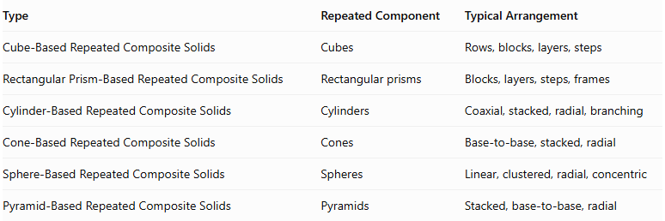
Type | Repeated Component | Typical Arrangement
Cube-Based Repeated Composite Solids | Cubes | Rows, blocks, layers, steps
Rectangular Prism-Based Repeated Composite Solids | Rectangular prisms | Blocks, layers, steps, frames
Cylinder-Based Repeated Composite Solids | Cylinders | Coaxial, stacked, radial, branching
Cone-Based Repeated Composite Solids | Cones | Base-to-base, stacked, radial
Sphere-Based Repeated Composite Solids | Spheres | Linear, clustered, radial, concentric
Pyramid-Based Repeated Composite Solids | Pyramids | Stacked, base-to-base, radial
Main distinction: Sphere-based repeated composite solids use spheres as their repeated building components. Their geometry is characterized by centers, radii, diameters, completely curved surfaces, and spherical contact or intersection relationships.

Applications
# Source: AI Source: Provided by: [Data Path: Persons Table -> ID Column: 1, Name_En Column: Motasem Essam] -> From: [ChatGPT] on [7/25/2026]
- Architecture: Designing spherical decorative structures and dome-like arrangements.
- Mechanical Engineering: Developing ball bearings and spherical mechanical components.
- Manufacturing: Producing spherical parts and repeated ball-shaped components.
- Materials Science: Studying particle packing and spherical particle arrangements.
- Chemistry: Representing molecular and atomic structures using spherical models.
- Mathematics Education: Teaching sphere volume, surface area, and spatial arrangements.
- Computer Graphics: Creating three-dimensional models using repeated spherical components.
- Game Design: Building environments and objects using spherical elements.
- Industrial Design: Developing ball-based products and decorative structures.
- Packaging Design: Studying the arrangement and packing of spherical objects.

Key Points
# Source: AI Source: Provided by: [Data Path: Persons Table -> ID Column: 1, Name_En Column: Motasem Essam] -> From: [ChatGPT] on [7/25/2026]
- Sphere-based repeated composite solids consist of multiple spheres arranged into a three-dimensional structure.
- Their components may have equal or different radii.
- They can form linear, clustered, stacked, coaxial, radial, ring-shaped, and grid-based arrangements.
- The volume of one sphere is:
$$V=\frac{4}{3}πr^{3}$$
- For $n$ identical non-overlapping spheres:
$$V_{total}=\frac{4}{3}nπr^{3}$$
- The surface area of one sphere is:
$$SA=4πr^{2}$$
- Externally tangent spheres have point contact, so their individual surface areas remain fully exposed.
- Intersecting spheres require additional calculations to determine their combined volume and external surface area.
- Hollow and concentric spherical structures require consideration of both inner and outer surfaces.

Conclusion
# Source: AI Source: Provided by: [Data Path: Persons Table -> ID Column: 1, Name_En Column: Motasem Essam] -> From: [ChatGPT] on [7/25/2026]
Sphere-Based Repeated Composite Solids are three-dimensional structures formed by combining multiple spheres in repeated arrangements. They include linear structures, clustered arrangements, stacked spheres, radial configurations, ring-shaped structures, nested spherical shells, and irregular clusters.
Their mathematical properties are based on spherical volume, surface area, radius, diameter, and the relationships between spherical components.
They provide a foundation for understanding more complex repeated composite solids and spherical arrangements used in mathematics, engineering, materials science, architecture, and geometric modeling.

